**(As of 24 JUL 2024)**

**Cross-Regional Committee Meeting  
Enhancing cooperation for a better future**

Thursday, 8 August 2024

08:00 – 09:30 (UTC-4 Eastern Daylight Time)

Conference Room 1684, Floor 16, Two United Nations Plaza (DC 2 Building),

New York, USA

Closed meeting, by invitation only

**Agenda Programme**

Chair: Mr. Antonius Wijanarto, President of UN-GGIM-AP

# Background

Starting in 2022, the five Regional Committees of UN-GGIM convened cross-regional side events at the twelfth and thirteenth sessions of the Committee of Experts. The discussions centred on common issues, challenges, and opportunities that are faced by all five regions.

It will be the first time that ESCAP as the secretariat of the Regional Committee of UN-GGIM Asia and the Pacific in collaboration with UNSD which is the Secretariat of UN-GGIM, organises an in-person meeting on the side of the fourteenth session of the Committee of Experts. The objective of the meeting is to agree on a work plan among all Regional Committees of UN-GGIM that further strengthens coordination, collaboration, and knowledge sharing among UN-GGIM Regional Committees.

# Presentations/Statements

The presentations and statement by each Regional Committee will seek to understand and analyse each region’s strengths, weaknesses, opportunities, and threats in terms of geospatial information such as:

**THREATS**

* *What risks could impact the region?*
* *What challenges does the region face?*

**OPPORTUNITIES**

* *What are emerging trends that could be leveraged?*
* *What capacities could be shared to other regions?*

**STRENGTHS**

* *What are the unique capacities and advantages of the region?*
* *What assets does the region have?*

**WEAKNESSES**

* *What can the region improve upon?*
* *What additional resources does the region need?*

# Discussion

The discussion can include what is the ultimate goal to which all five regional committees are working towards /wish to achieve. The committee of experts’ strategic framework for 2018-2022 was as shown in the diagram below. The Regional Committees could use/adapt GGIM’s vision and mission or create their own.

# 

# Expected Outcomes

The side meeting will help the Regional Committees to:

* Understand each region’s perspectives on strengths, weaknesses, opportunities, threats and proposals on cross-regional committees’ cooperation
* Understand the scope, tasks and output to be accomplished under the UN-GEGN/UN-GGIM Collaborative project and to identify regional leads to support project implementation and execution of the survey
* Foster networking across Regional Committees to strengthen coordination and cooperation
* Agree on a work plan for 2024-2025
* Agree on the next lead regional committee for 2025

# Agenda

|  |  |  |  |
| --- | --- | --- | --- |
| **07:45-08:00** | **Arrival at the meeting room and preparations** |  |  |
| **08:00-08:10** | **Opening** |  |  |
| Opening Remarks by the President UN-GGIM-AP | Mr. Anton Wijanarto | 5 mins |
| Welcome by the host Secretariat of UN-GGIM and the Secretariat of UN-GGIM-AP | UNSD/ESCAP | 5mins |
| **08:10-09:10** | **Presentations/Statements** |  |  |
| UN-GEGN: *Collaborative Project Proposal between UN-GEGN and UN-GGIM* | Mr. Ade K. Mulyana/ Ms. Cecille Blake | 10 mins |
| UN-GGIM Africa | Ms. Maroale Chauke | 5 mins |
| UN-GGIM Americas | Ms. Sofia Crisostomo | 5 mins |
| UN-GGIM Arab States | TBC | 5 mins |
| UN-GGIM Asia and the Pacific | Mr. Victor Khoo | 5 mins |
| UN-GGIM Europe | TBC | 5 mins |
| UN-GGIM Secretariat | TBC | 5 mins |
| Discussion | TBC |  |
| **09:10-09:30** | **Cross-Regional Committees’ cooperation** |  |  |
| Proposed joint programme/project for 2025 Next Cross-Regional Committees meeting and lead |  |  |
| Wrap-up |  |  |

# Organisers

Mr. Chul Min Lee – United Nations Economic and Social Commission for Asia and the Pacific

[chul.lee@un.org](mailto:chul.lee@un.org)

Ms. Shiyue Fan – United Nations Economic and Social Commission for Asia and the Pacific

[shiyue.fan@un.org](mailto:shiyue.fan@un.org)

# Venue Information

**Two United Nations Plaza (DC 2 Building)**

Millennium UN Plaza,

2 United Nations Plaza,

New York, NY 10017,

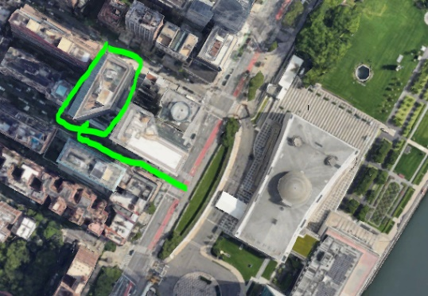United States

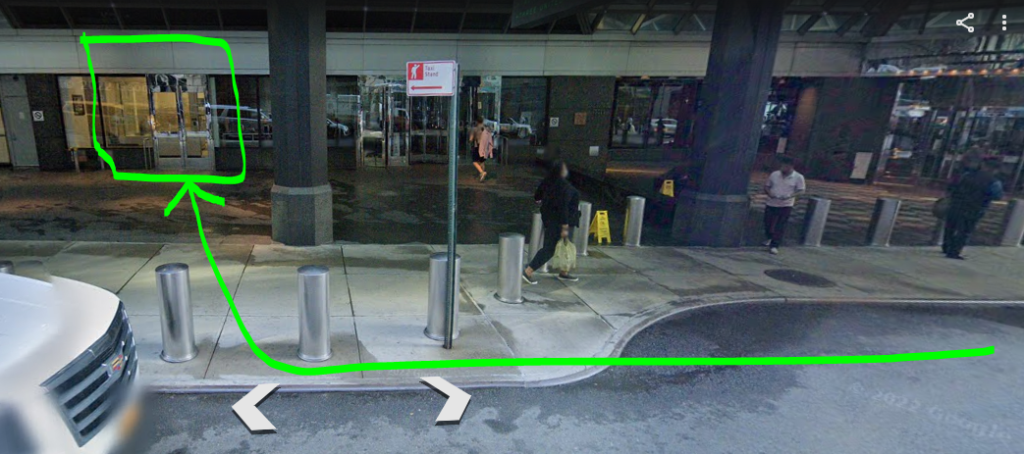

**Meeting Room:**

Conference Room 1684, Floor 16